T

TIBCO BusinessEvents: Views

Product Suite | TIBCO BusinessEvents
Product | Views
Product Version | 5.1
Initial Author | Anand Patil

Copyright Notice
COPYRIGHT© 2011 TIBCO Software Inc. This document is unpublished and the foregoing notice is affixed to protect TIBCO Software Inc. in the event of inadvertent publication. All rights reserved. No part of this document may be reproduced in any form, including photocopying or transmission electronically to any computer, without prior written consent of TIBCO Software Inc. The information contained in this document is confidential and proprietary to TIBCO Software Inc. and may not be used or disclosed except as expressly authorized in writing by TIBCO Software Inc. Copyright protection includes material generated from our software programs displayed on the screen, such as icons, screen displays, and the like.
Trademarks
Technologies described herein are either covered by existing patents or patent applications are in progress. All brand and product names are trademarks or registered trademarks of their respective holders and are hereby acknowledged.
Confidentiality
The information in this document is subject to change without notice. This document contains information that is confidential and proprietary to TIBCO Software Inc. and may not be copied, published, or disclosed to others, or used for any purposes other than review, without written authorization of an officer of TIBCO Software Inc. Submission of this document does not represent a commitment to implement any portion of this specification in the products of the submitters.
Content Warranty
The information in this document is subject to change without notice. THIS DOCUMENT IS PROVIDED "AS IS" AND TIBCO MAKES NO WARRANTY, EXPRESS, IMPLIED, OR STATUTORY, INCLUDING BUT NOT LIMITED TO ALL WARRANTIES OF MERCHANTABILITY OR FITNESS FOR A PARTICULAR PURPOSE. TIBCO Software Inc. shall not be liable for errors contained herein or for incidental or consequential damages in connection with the furnishing, performance or use of this material.
For more information, please contact:
TIBCO Software Inc.
3303 Hillview Avenue
Palo Alto, CA 94304
USA
Table of Contents
TIBCO BusinessEvents: Views 1
1 Change Log 4
1.1 Related Documents 4
2 Introduction 5
2.1 Main Objective 5
2.2 Intended Usage 5
2.3 Scope 5
2.4 Audience 5
3 Acronyms and Vocabulary 6
4 General Requirements 8
4.1 Packaging 8
5 Non-Functional Requirements 9
5.1 Web browser support 9
5.2 Server support 9
5.3 Port let support 9
5.4 Ease of use and customization 9
5.5 Performance 9
6 Functional Requirements 9
6.1 Drill Down Page 9
6.1.1 User Interactions 9
6.2 Query Manager 10
6.2.1 User Interactions 10
6.2.2 Condition Operators 12
6.3 Table Tree Widget 15
6.3.1 User Interactions 15
6.4 Related Concepts Page 20
6.4.1 User Interactions 20
7 High Level Design 20
7.1 Drill Down Page 21
7.1.1 Schema Design 21
7.1.2 User Interactions 21
7.2 Query Manager 22
7.2.1 Schema Design 22
7.2.2 User Interactions 22
7.1 Table Tree Widget 25
7.1.1 Schema Design 25
7.1.2 API Design 25
7.1.3 User Interactions 27
8 Technology Overview 40

Change Log
.
Date | Version | Name | Description
06/02/2011 | 1.0 | Anand Patil | Initial doc
08/05/2011 | 1.1 | Anand Patil | Updated to reflect API changes

Related Documents
Document Title | Revision Number | Author

Introduction

Main Objective

The document explains the drill down page’s user interactions and the functionality of the page. The ‘drill down’ page provides the second level of information to a consumer of BE Views dashboard. Typically a user would observe the dashboard for any unique situations (indicated either by simply an abnormal data change or a visual alert). Once a unique situation is found, the user can ‘click’ on the concerned data point to launch the drill down page.

Intended Usage

The document is intended to be used to understand how the current drill down page works and explains all the interactions the user can do with the page. This will help UX group to design a better interface and help the UI engineers do a better design.

Scope
The scope of this document is limited to the porting of the current drill down page. The current drill down page is written in HTML/JavaScript and is limited to only Internet Explorer. This severely limits the expansion of the supported browser. By porting the page to Flex, we will make BE Views uniform technology wise and open up the entire product to be accessed from any platform that supports Flash/Flex.

Audience

The document is intended for User Interaction Designers, Developers, Architects, QA and Managers.

Acronyms and Vocabulary
The diagrams below explain the various terms used in the document.

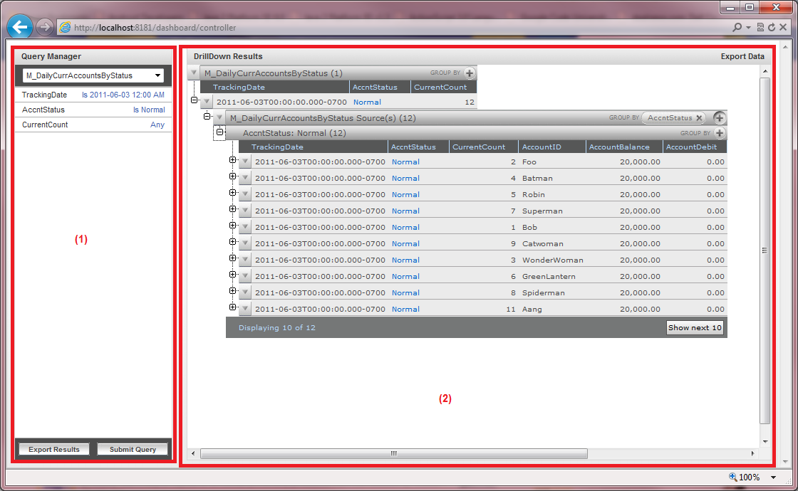
Figure 1 Drill down page

- Query Manager
The “query manager” represents the query manager component. It is an optional component. It allows the user to query the metric/concepts in the project.
- Table Tree Widget
The “table tree widget” represents the results of a query. The query can be either from the query manager or from a data point drilldown action executed on the dashboard
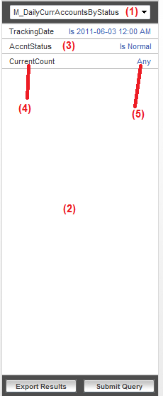
Figure 2 Query Manager

- Metric/Concept List
The ‘Metric/Concept’ list shows the alphabetically sorted list of metrics and concepts which are query-able.
- Fields Section
The ‘Fields Section’ represents the area where the fields of the selected metric/concept are shown
- Field Row
The ‘field row’ represents a single field of the selected metric/concept
- Field Name
The ‘field name’ represents the name of the field
- Condition Text
The ‘condition text’ represents the condition on the field

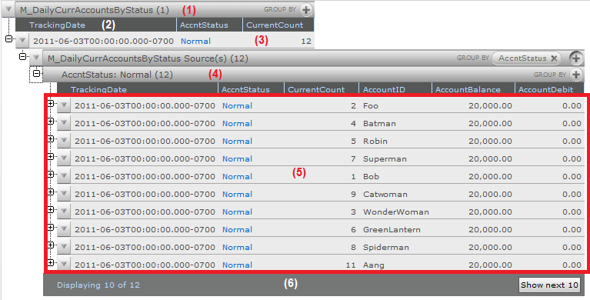
Figure 3 Table Tree Widget

- Type Row
The ‘type row’ represents a type. It can contain either one or more group by row(s) or one type table. It provides information like the type name, count and group by field options
- Type Table Header Row
The ‘type table header row’ represents the header row of a type table. It contains the columns being shown and allows sorting on each column
- Type Data Row
The ‘type data row’ represents a single instance of a type. It is selectable. Each type data row can be expanded to view one or more ‘type row’(s)
- Group By Row
The ‘group by row’ represents a single group by value. Each ‘group by row’ provides information like the ‘group by value’, count. It can contain one type table.
- Type Table
The ‘type table’ represents a set of data. The type of the data is based on the parent type row of the ‘type table’. The ‘type table’ contains one ‘type table header row’, one or more ‘type data row’(s) and an optional ‘pagination row’
- Pagination Row
The ‘pagination row’ represents pagination information. It is an optional row which is shown only if the type table is showing part of the complete data set. It show information about which row set is being shown as well as the total number of rows. It also contains buttons to navigate the pages in the data set.

General Requirements

Packaging
The packaging will be within the current BE Views add-on

Non-Functional Requirements

Web browser support
All modern browsers and platforms which support Flash Player 10.X will be supported. The support for 64-bit platforms will be beta, since Adobe was only recently launched a beta version of the 64-bit flash player

Server support
The server development will be within the BE Views current technology and architecture.

Port let support
TBD

Ease of use and customization
TBD

Performance
The performance of the drill down page should be better than then current incarnation. We should attempt to optimize the amount of data sent from the server to the front end to reduce network usage and parsing processing in the front end.

Functional Requirements

The drill down page provides user with the ability to see what caused a change. The page is comprised of a ‘query manager’ and a ‘table tree widget’. The ‘query manager’ is an optional component.

Drill Down Page

User Interactions

Page Resizing

Triggering Action | Maximize the host browser window  Resize the host browser window
User Feedback | Browser Window resizes
Success | The drill down page resizes adjusting the dimensions of the components within appropriately
Failure | ??

Component Resizing

Triggering Action | Repositioning of the splitter between query manager and table tree widget
User Feedback | Continuous feedback of new widths
Success | The query manager and the table tree widget widths adjust appropriately
Failure | ??

Query Manager

User Interactions

Initial Empty View

Triggering Action | Click on ‘search’ link in the dashboard header
User Feedback | New browser window opened  Drilldown page loaded
Success | Empty widget shown  ‘Select One…’ selected in metric/concept drop down  The metric/concept list is alphabetically sorted  Empty fields section is shown  Export and query execution buttons are disabled
Failure | In place message showing what went wrong

Initial Selected View

Triggering Action | Click on ‘drilldown’ link on a data point on the dashboard
User Feedback | New browser window opened  Drilldown page loaded
Success | The metric/concept list is alphabetically sorted  Underlying metric selected  The fields section shows the metric fields with the conditions
Failure | In place message showing what went wrong

Metric/Concept Selection

Triggering Action | Selecting a new metric/concept in the metric/concept list
User Feedback | Busy cursor
Success | Normal cursor  The new metric/concept is selected  The fields section shows fields of the selected entity with no conditions  The export results and submit query buttons are enabled
Failure | Normal cursor  Select ‘Select One’ in the metric/concept list  Empty fields section is shown  The export results and submit query buttons are disabled  Alert box showing what went wrong with details, if available

Specifying Condition

Triggering Action | Clicking on the field to launch a menu and then clicking on ‘Specify Condition’ OR  Clicking on the field to expand it (accordion style)
User Feedback | Busy cursor
Success | Normal cursor  A condition dialog is shown OR  The condition area is shown below the field
Failure | Normal cursor  Alert box showing what went wrong with details, if available

Resetting Condition

Triggering Action | Clicking on the field to launch a menu and then clicking on ‘Reset Condition’ OR  Clicking on the field to expand it (accordion style) [How do we trigger reset in this style?]
User Feedback | Busy cursor
Success | Normal cursor  The condition information next to the field changes to ‘Any’
Failure | Normal cursor  The condition information is not changed  Alert box showing what went wrong with details, if available

Executing a query

Triggering Action | Clicking on the ‘Submit Query’ / ‘Execute Query’ button
User Feedback | Busy cursor
Success | Normal cursor  The table tree widget shows the query results  The table tree widget menus are enabled
Failure | Normal cursor  The table tree widget does not change  Alert box showing what went wrong with details, if available

Exporting results

Triggering Action | Clicking on the ‘Export Results’ / ‘Export Data’ button
User Feedback | Export dialog is shown with default options
Success | NA
Failure | Alert box showing what went wrong with details, if available

Exporting dialog OK

Triggering Action | Clicking on ‘ok’ button in the export dialog
User Feedback | Dismiss the dialog  Busy cursor
Success | Normal cursor  File save dialog to save export results
Failure | Normal cursor  Alert box showing what went wrong with details, if available

Exporting results Cancel

Triggering Action | Clicking on ‘cancel’ button in the export dialog
User Feedback | Dismiss the dialog
Success | NA
Failure | NA

Condition Operators

String

- Contains
- Is
- Is Not
- Starts With
- Ends With

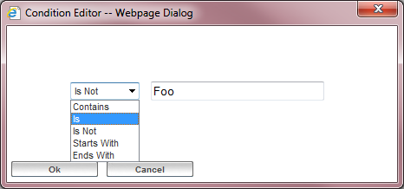
Figure 4 String Operators

Number

- Is
- Is Not
- Is Greater Than Equal To
- Is Greater Than
- Is Less Than Equal To
- Is Less Than
- Is In The Range

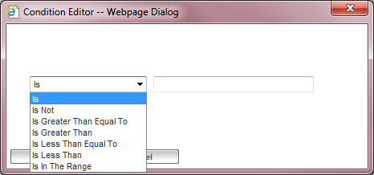
Figure 5 Number Operators

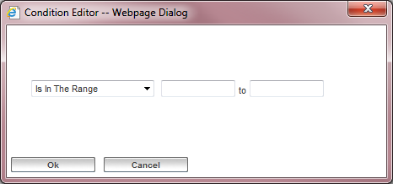
Figure 6 Number Range Operator

DateTime

- Is
- Is Today
- Is Before
- Is After
- Is In The Last
- Is In The Range

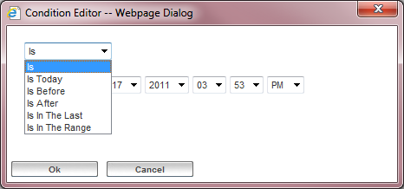
Figure 7 DateTime Operator

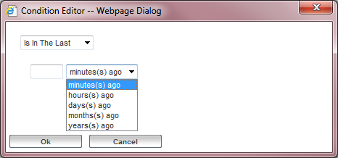
Figure 8 DateTime Is In The Last Operator

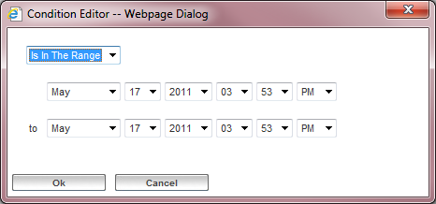
Figure 9 DateTime Range Operator

Boolean
- None

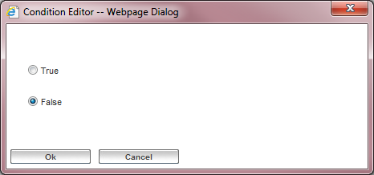
Figure 10 Boolean Operator

Table Tree Widget

User Interactions

Initial Empty View

Triggering Action | Click on ‘search’ link in the dashboard header
User Feedback | New browser window opened  Drilldown page loaded
Success | Empty widget shown  Export menu is disabled
Failure | In place message shown showing what went wrong

Initial Full View

Triggering Action | Click on ‘drilldown’ link on a data point on the dashboard
User Feedback | New browser window opened  Drilldown page loaded
Success | Single expanded type row shown  The type table shown  Pagination row added if needed
Failure | In place message shown showing what went wrong

Expanding a data row

Triggering Action | Click on ‘plus’ before the data row
User Feedback | Busy cursor  ‘plus’ changes to ‘indeterminate’ progress bar
Success | Normal cursor  ‘plus’ changes to ‘minus’,  New type row(s) added as children under the data row
Failure | Normal cursor  ‘plus’ stays ‘plus’.  Alert box showing what went wrong with details, if available

Collapsing a data row

Triggering Action | Click on ‘minus’ before the data row
User Feedback | Busy cursor  ‘minus’ changes to ‘indeterminate’ progress bar
Success | Normal cursor  ‘minus’ changes to ‘plus’  all children under the data row removed
Failure | Normal cursor  ‘minus’ stays ‘minus’  Children stay in place  Alert box showing what went wrong with details, if available

Selecting a data row

Triggering Action | Clicking anywhere on the data row
User Feedback | Background color of the data row changes
Success | NA
Failure | NA

Sorting a type table

Triggering Action | Click on column header of a type table
User Feedback | Busy cursor  Show ‘spinner’ in the clicked column
Success | Normal cursor  Remove ‘spinner’  All children of the type table removed  Replace the type table with the new sorted type table  Pagination row added if needed
Failure | Normal cursor  Remove ‘spinner’  Type table stays  Alert box showing what went wrong with details, if available

Expanding a type row

Triggering Action | Click on ‘plus’ before the type row
User Feedback | Busy cursor  ‘plus’ changes to ‘indeterminate’ progress bar
Success | Busy cursor  ‘plus’ changes to ‘minus’  New type table added as child under the type row  Type row width adjusted to the type table width  Pagination row added if needed
Failure | Normal cursor  ‘plus’ stays ‘plus’  Alert box showing what went wrong with details, if available

Collapsing a type row

Triggering Action | Click on ‘minus’ before the type row
User Feedback | Busy cursor  ‘minus’ changes to ‘indeterminate’ progress bar
Success | Normal cursor  ‘minus’ changes to ‘plus’  Child type table removed  Type row width adjusted to the preferred width
Failure | Normal cursor  ‘minus’ stays ‘minus’  child type table stays  Alert box showing what went wrong with details, if available

Applying Group By

Triggering Action | Selecting field from ‘group by’ drop down in type row
User Feedback | Busy cursor  Can we show spinner somewhere?
Success | Normal cursor  Child type table replaced with group by row(s)
Failure | Normal cursor  Child type table stays.  Alert box showing what went wrong with details, if available

Expanding a group by row

Triggering Action | Click on ‘plus’ before the group by row
User Feedback | Busy cursor  ‘plus’ changes to ‘indeterminate’ progress bar
Success | Normal cursor  ‘plus’ changes to ‘minus’,  New type table added as child under the group by row  Pagination row added if needed  Group by row width adjusted to the type table width
Failure | Normal cursor  ‘plus’ stays ‘plus’.  Alert box showing what went wrong with details, if available

Collapsing a group by row

Triggering Action | Click on ‘minus’ before the group by row
User Feedback | Busy cursor  ‘minus’ changes to ‘indeterminate’ progress bar
Success | Normal cursor  ‘minus’ changes to ‘plus’  Child type table removed  Group by row width adjusted to the preferred width
Failure | Normal cursor  ‘minus’ stays ‘minus’  Child type table stays  Alert box showing what went wrong with details, if available

Sorting a grouped type table

Triggering Action | Click on column header of a type table
User Feedback | Busy cursor  Show ‘spinner’ in the clicked column
Success | Normal cursor  Remove ‘spinner’  Replace the type table with the new sorted type table  All children of the type table removed.
Failure | Normal cursor  Remove ‘spinner’  Type table stays  Alert box showing what went wrong with details, if available

Removing Group By

Triggering Action | Selecting ‘None’ from ‘group by’ drop down in type row
User Feedback | Busy cursor  Can we show spinner somewhere?
Success | Normal cursor  Set of group by row replaced by child type table  All children of group by row(s) removed
Failure | Normal cursor  Child type table stays  Alert box showing what went wrong with details, if available

Type Table Pagination: Append Mode

Triggering Action | Clicking on ‘Show Next …’ button in the pagination row
User Feedback | Busy cursor  Can we show spinner somewhere?
Success | Normal cursor  New data row(s) appended to the type table  Pagination row removed if no longer needed
Failure | Normal cursor  Pagination row remains  Alert box showing what went wrong with details, if available

Type Table Pagination: Replace Mode

Triggering Action | Clicking on ‘Show Next …’ button in the pagination row
User Feedback | Busy cursor  Can we show spinner somewhere?
Success | Normal cursor  Type table data rows replaced with new data rows  Pagination row updated
Failure | Normal cursor  Alert box showing what went wrong with details, if available

Exporting results

Triggering Action | Clicking on the ‘Export Results’ / ‘Export Data’ button
User Feedback | Export dialog is shown with default options
Success | NA
Failure | Alert box showing what went wrong with details, if available

Exporting dialog OK

Triggering Action | Clicking on ‘ok’ button in the export dialog
User Feedback | Dismiss the dialog  Busy cursor
Success | Normal cursor  File save dialog to save export results
Failure | Normal cursor  Alert box showing what went wrong with details, if available

Exporting results Cancel

Triggering Action | Clicking on ‘cancel’ button in the export dialog
User Feedback | Dismiss the dialog
Success | NA
Failure | NA

Related Concepts Page

User Interactions

Initial View

Triggering Action | Clicking on ‘Show All Related Concepts’ menu item on a ‘concept’ data row
User Feedback | Busy Cursor
Success | Normal Cursor  A new browser window showing a fully expanded table tree with all the related concepts
Failure | Normal Cursor  Alert box showing what went wrong with details, if available

Collapsing Type Row/Data Row

Triggering Action | Clicking on ‘minus’ sign before type row or data row
User Feedback | Busy Cursor
Success | Normal Cursor  ‘minus’ becomes ‘plus’  All children below the target row removed from view
Failure | Normal Cursor  ‘minus’ remains ‘minus’  All children stay in place  Alert box showing what went wrong with details, if available

Expanding Type Row/Data Row

Triggering Action | Clicking on ‘plus’ sign before type row or data row
User Feedback | Busy Cursor
Success | Normal Cursor  ‘plus’ becomes ‘minus’  Appropriate children are added under the target row  Type row(s) under data row  Data row(s) under type row
Failure | Normal Cursor  ‘plus’ remains ‘plus’  Alert box showing what went wrong with details, if available

High Level Design

The UI-server interactions will be XML over HTTP similar to how the dashboard currently communicates with the dashboard agent. Each drill down page instance will run in its own session.

Drill Down Page

Schema Design
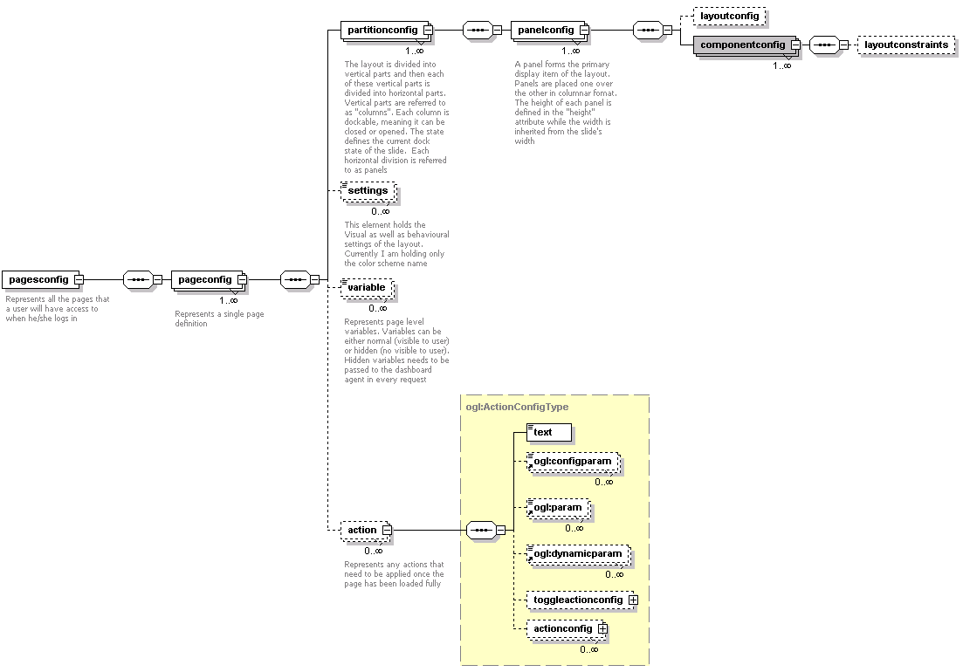

User Interactions

Launching

Triggering Actions

The ‘search’ link in the dashboard header | http://localhost:8181/searchpage.html?stoken=a1c535a8-fa11-4ca5-b15b-d74cc0fa28d5
A ‘drilldown’ link on a data point. | http://localhost:8181/searchpage.html?stoken=a1c535a8-fa11-4ca5-b15b-d74cc0fa28d5&componentid=92C7326C-1A29-E821-79E6-B1B5F0EF6D2C&seriesid=8C2E9FC8-3C2C-E7DC-79F4-806FAB9D4983&tupid=187

Client Processing Steps

- Parse the URL and set all incoming parameters as kernel boot parameters
- Get Layout (pass all boot parameters to the dashboard agent)
- Honor hidden page variables and page level actions (keep session alive)
Layout XML

<pagesconfig id="1" defaultpage="1" name="Foo">
<pageconfig id="1" displaymode="inplace" name="Drilldown Page">
<partitionconfig id="1" span="10%">
<panelconfig id="1" title="Query Manager" span="100%">
<componentconfig type="QueryManagerComponent" id="1" title="Query Manager" name="QueryManager"/>
</panelconfig>
</partitionconfig>
<partitionconfig id="2" span="90%">
<panelconfig id="1" title="DrillDown Results" span="100%">
<componentconfig type="SearchViewComponent" id="1" title="DrillDown Result" name="SearchViewComponent"/>
</panelconfig>
</partitionconfig>
<variable name="sessionid" datatype="string" type="hidden">12344</variable>
<action command="recurring">
<configparam name="period">59000</configparam>
<action command="launchinternallink">
<param name="command">keepsessionalive</param>
</action>
</action>
</pageconfig>
</pagesconfig>

Page Resizing

The framework provides this feature

Component Resizing

The framework provides this feature

Query Manager

Schema Design

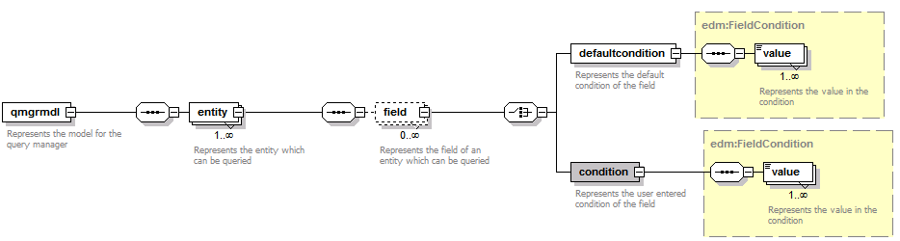

User Interactions

Initial Empty View

Request | - command = getqmgrmodel  - sessionid = sessionid variable from pagesconfig
Success | <qmgrmdl selectedentityid="-1">  <entity id="1" name="Foo"/>  <entity id="2" name="Bar"/>  </qmgrmdl>
Failure | Standard Failure Response

Initial Selected View

Request | - command = getqmgrmodel  - sessionid = sessionid variable from pagesconfig
Success | <qmgrmdl selectedentityid="2">  <entity id="1" name="Foo"/>  <entity id="2" name="Bar">  <field id="1" name="field1" datatype="boolean">  <defaultcondition operator="Is">  <value>true</value>  </defaultcondition>  </field>  <field id="2" name="field2" datatype="string">  <condition operator="Is">  <value>Yahoo</value>  </condition>  </field>  <field id="3" name="field3" datatype="datetime">  <condition operator="Is In The Range">  <value>123456789746</value>  <value>654797412548</value>  </condition>  </field>  <field id="4" name="field4" datatype="integer">  <condition operator="Is Greater Than Equal To">  <value>45555</value>  </condition>  </field>  </entity>  </qmgrmdl>
Failure | Standard Failure Response

Metric/Concept Selection

Request | - command = getfields  - sessionid = sessionid variable from pagesconfig  - entityid = id of selected entity
Success | <qmgrmdl selectedentityid="2">  <entity id="2" name="Bar">  <field id="1" name="field1" datatype="boolean">  <defaultcondition operator="Is">  <value>Yahoo</value>  </defaultcondition>  </field>  <field id="2" name="field2" datatype="string">  <defaultcondition operator="Is">  <value>Yahoo</value>  </defaultcondition>  </field>  <field id="3" name="field3" datatype="datetime">  <defaultcondition operator="Is">  <value>123456789746</value>  </defaultcondition>  </field>  <field id="4" name="field4" datatype="integer">  <defaultcondition operator="Is">  <value>45555</value>  </defaultcondition>  </field>  </entity>  </qmgrmdl>
Failure | Standard Failure Response

The query manager should also maintain an internal XML which represent what is the user wishes to query. Below is what that XML should look like when the user selects a new metric/concept

<qmgrmdl selectedentityid="2">
<entity id="2" name="Bar">
</entity>
</qmgrmdl>

Specifying Condition

Request | None
Success | [store the information internally in query model xml]
Failure

The query manager should also maintain an internal XML which represent what is the user wishes to query. Below is what that XML should look like when the user specifies a condition. Note that every field which has a condition applied should be added as a new <field>…</field> node. Also note that we are using <condition>…</condition> inside the <field>…</field> and NOT <defaultcondition>…</defaultcondition>

<qmgrmdl selectedentityid="2">
<entity id="2" name="Bar">
<field id="1" name="field1" datatype="boolean">
<condition operator="Is">
<value>Yahoo</value>
</condition>
</field>
<field id="4" name="field4" datatype="integer">
<condition operator="Is In The Range">
<value>45555</value>
<value>60000</value>
</condition>
</field>
</entity>
</qmgrmdl>

Resetting Condition

Request | None
Success | [store the information internally in query model xml]
Failure

The query manager should also maintain an internal XML which represent what is the user wishes to query. Below is what that XML should look like when the user resets a condition. Note that we remove the field whose condition has been reset.

<qmgrmdl selectedentityid="2">
<entity id="2" name="Bar">
<field id="1" name="field1" datatype="boolean">
<condition operator="Is">
<value>Yahoo</value>
</condition>
</field>
</entity>
</qmgrmdl>

Executing a query

Request | - command = executequery  - sessionid = sessionid variable from pagesconfig  - querymodel = <the internal query model XML>
Success | - Standard Empty Response  - Fire an client side event to refresh ‘SearchViewComponent’
Failure | Standard Failure Response

Exporting results

Request | None
Success
Failure

Exporting dialog OK

Request | - command = exportquery  - sessionid = sessionid variable from pagesconfig  - querymodel = < the internal query model XML >  - exportformat = xml/csv
Success | Export Data
Failure | Standard Failure Response??

Exporting results Cancel

Request | None
Success
Failure

Table Tree Widget

Schema Design

Refer to “textmodel” and “visualizationdata” in ogl.xsd

API Design

The API for the table tree widget is documented below. We will look into the various APIs and what the parameters for each are and what they mean within the context of the API. We will eventually map these APIs to the user interactions (including the response XMLs)

Possible Parameters

- sessionid – The sessionid of the page. Supplied as a ‘hidden’ variable in the pagesconfig named as ‘sessionid’
- path – A unique path which identifies the target node being worked on. The syntax of the path is [typeid[/[instanceid,fieldname=fieldvalue]]?]+ where ‘typeid’ is the id of the type, ‘instanceid’ is the id of the data, fieldname is the name of a field in the type represented by ‘typeid’ and fieldvalue is a value for the fieldname. The escape character is ‘/’. E.g. Let’s assume we have a concepts hierarchy as shown below

  - Concept C1 [typeid=C1]
    - Field F1
    - Concept C2 [typeid=C2]
      - Field F2
And a instance hierarchy as shown below
  - Instance of C1 [id=123]
    - F1 = Foo
    - Instance of C2 [id=456]
      - F2 = Bar

Some possible paths are
C1 | Indicates type C1
C1/F1=Foo | Indicates instances of C1 with F1 == Foo
C1/123 | Indicates instance of C1 with id as 123
C1/123/C2 | Indicates C2 under the instance of C1 with id as 123
C1/123/C2/456 | Indicates instance of C2 with id as 456 under the instance of C1 with id as 123
C1/123/C2/F2=Bar | Indicates all instances of C2 with F2 == Bar under the instance of C1 with id as 123
C1/123/C2/F//2=Bar | Indicates all instances of C2 with F/2 == Bar under the instance of C1 with id as 123
C1/123/C2/F2=B/=ar | Indicates all instances of C2 with F2 == B=ar under the instance of C1 with id as 123

- sortfield – Indicates which field to use for sorting. Only one field is supported at a time
- sortfielddirection – Indicates which direction to use for sorting. Is Optional. Can be either ‘asc’ or ‘desc’
- startindex – Indicates the index from which to start a type table page
- command – the command which determines the underlying business logic

Command | Description | Parameters
getdata | Returns the data which forms the ‘type table’  OR  Returns the child types under a data row  OR  Returns the group by values for a particular group by field selection | sessionid  path [optional]  sortfield [optional]  sortfielddirection [optional]  groupbyfield [optional]  groupbyfieldvalue [optional]  startindex[optional]
removedata | Notifies the server that a ‘type table’ has been removed from client side (typically when user collapses the type row)  OR  Notifies the server that ‘child types’ have been removed from the client side (typically when user collapses the data row) | sessionid  path  groupbyfield [optional]  groupbyfieldvalue [optional]

User Interactions

Initial Empty View

Request | - command = getdata  - sessionid = sessionid variable from pagesconfig
Success | Standard Success Response with EMPTY content
Failure | Standard Failure Response

Initial Full View

Request | - command = getdata  - sessionid = sessionid variable from pagesconfig
Success [empty data] | <textmodel componentid="" componentname="" componenttype="TypeTable">  </textmodel>
Success [with data] | <textmodel componentid="C5B7B8DE-3F41-98EA-DB86-78F77322B1CC" componentname="M_DailyCurrAccountsByStatus(1)" componenttype="TypeTable">  <actionconfig disabled="false">  <text>ROOT</text>  <actionconfig>  <text>GROUPBY</text>  <actionconfig command="userdefined">  <text>Tracking Date</text>  </actionconfig>  <actionconfig command="userdefined">  <text>AccntStatus</text>  </actionconfig>  <actionconfig command="userdefined">  <text>CurrentCount</text>  </actionconfig>  </actionconfig>  <actionconfig disabled="false">  <text>ACTIONS</text>  <actionconfig disabled="false">  <text>Show Related Concepts</text>  <configparam name="dialogname">relatedconcepts</configparam>  </actionconfig>  </actionconfig>  </actionconfig>  <visualizationdata componentid="C5B7B8DE-3F41-98EA-DB86-78F77322B1CC">  <datarow id="1" templatetype="header" visualtype="TypeTableHeaderRow" templateid="1">  <datacolumn id="0">  <displayvalue>TrackingDate</displayvalue>  </datacolumn>  <datacolumn id="1">  <displayvalue>AccntStatus</displayvalue>  </datacolumn>  <datacolumn id="2">  <displayvalue>CurrentCount</displayvalue>  </datacolumn>  </datarow>  <datarow id="2" templatetype="data" visualtype="TypeDataRow" templateid="2">  <datacolumn id="0">  <displayvalue>2011-06-03T00:00:00.000-700</displayvalue>  <value>122354655468787</value>  </datacolumn>  <datacolumn id="1">  <value>Normal</value>  </datacolumn>  <datacolumn id="2">  <displayvalue>12</displayvalue>  <value>12</value>  </datacolumn>  </datarow>  </visualizationdata>  <textconfig componentid="C5B7B8DE-3F41-98EA-DB86-78F77322B1CC" maxrows="10">  <rowconfig id="1" templatetype="header" visualtype="TypeTableHeaderRow">  <columnconfig id="0" align="left"/>  <columnconfig id="1" align="left"/>  <columnconfig id="2" align="left"/>  </rowconfig>  <rowconfig id="2" templatetype="data" visualtype="TypeDataRow">  <columnconfig id="0" align="left"/>  <columnconfig id="1" align="left"/>  <columnconfig id="2" align="right"/>  </rowconfig>  </textconfig>  </textmodel>
Failure | Standard Failure Response

Expanding a data row

Request | - command = getdata  - sessionid = sessionid variable from pagesconfig  - path = the path of the data row expanded
Success | <textmodel componentid="C5B7B8DE-3F41-98EA-DB86-78F77322B1CC" componentname="M_DailyCurrAccountsByStatus(1)" componenttype="TypeTable">  <visualizationdata componentid="C5B7B8DE-3F41-98EA-DB86-78F77322B1CC">  <datarow id="1" templatetype="header" visualtype="TypeRow" templateid="1">  <datacolumn id="0">  <displayvalue>M_DailyCurrAccountsByStatus Sources(12)</displayvalue>  </datacolumn>  </datarow>  </visualizationdata>  <textconfig componentid="C5B7B8DE-3F41-98EA-DB86-78F77322B1CC">  <rowconfig id="1" templatetype="header" visualtype="TypeRow">  <columnconfig id="0" align="left"/>  </rowconfig>  </textconfig>  </textmodel>
Failure | Standard Failure Response

Collapsing a data row

Request | - command = removedata  - sessionid = sessionid variable from pagesconfig  - path = the path of the data row collapsed
Success | Standard Success Response
Failure | Standard Failure Response

Selecting a data row

Request | NA
Success | NA
Failure | NA

Sorting a type table

Request | - command = getdata  - sessionid = sessionid variable from pagesconfig  - path = <none if root type table sorted> else the path of the parent type row  - sortfield = <somefieldname>  - sortfielddirection
Success | <textmodel componentid="C5B7B8DE-3F41-98EA-DB86-78F77322B1CC" componentname="M_DailyCurrAccountsByStatus(1)" componenttype="TypeTable">  <actionconfig disabled="false">  <text>ROOT</text>  <actionconfig>  <text>GROUPBY</text>  <actionconfig command="userdefined">  <text>Tracking Date</text>  </actionconfig>  <actionconfig command="userdefined">  <text>AccntStatus</text>  </actionconfig>  <actionconfig command="userdefined">  <text>CurrentCount</text>  </actionconfig>  </actionconfig>  <actionconfig disabled="false">  <text>ACTIONS</text>  <actionconfig disabled="false">  <text>Show Related Concepts</text>  <configparam name="dialogname">relatedconcepts</configparam>  </actionconfig>  </actionconfig>  </actionconfig>  <visualizationdata componentid="C5B7B8DE-3F41-98EA-DB86-78F77322B1CC">  <datarow id="1" templatetype="header" visualtype="TypeTableHeaderRow" templateid="1">  <datacolumn id="0">  <displayvalue>TrackingDate</displayvalue>  <sortvalue>asc</sortvalue>  </datacolumn>  <datacolumn id="1">  <displayvalue>AccntStatus</displayvalue>  </datacolumn>  <datacolumn id="2">  <displayvalue>CurrentCount</displayvalue>  </datacolumn>  </datarow>  <datarow id="2" templatetype="data" visualtype="TypeDataRow" templateid="2">  <datacolumn id="0">  <displayvalue>2011-06-03T00:00:00.000-700</displayvalue>  <value>122354655468787</value>  </datacolumn>  <datacolumn id="1">  <value>Normal</value>  </datacolumn>  <datacolumn id="2">  <displayvalue>12</displayvalue>  <value>12</value>  </datacolumn>  </datarow>  </visualizationdata>  <textconfig componentid="C5B7B8DE-3F41-98EA-DB86-78F77322B1CC" maxrows="10">  <rowconfig id="1" templatetype="header" visualtype="TypeTableHeaderRow">  <columnconfig id="0" align="left"/>  <columnconfig id="1" align="left"/>  <columnconfig id="2" align="left"/>  </rowconfig>  <rowconfig id="2" templatetype="data" visualtype="TypeDataRow">  <columnconfig id="0" align="left"/>  <columnconfig id="1" align="left"/>  <columnconfig id="2" align="right"/>  </rowconfig>  </textconfig>  </textmodel>
Failure | Standard Failure Response

Expanding a type row

Request | - command = getdata  - sessionid = sessionid variable from pagesconfig  - path = the path of the type row expanded
Success | <textmodel componentid="C5B7B8DE-3F41-98EA-DB86-78F77322B1CC" componentname="M_DailyCurrAccountsByStatus(1)" componenttype="TypeTable">  <actionconfig disabled="false">  <text>ROOT</text>  <actionconfig>  <text>GROUPBY</text>  <actionconfig command="userdefined">  <text>Tracking Date</text>  </actionconfig>  <actionconfig command="userdefined">  <text>AccntStatus</text>  </actionconfig>  <actionconfig command="userdefined">  <text>CurrentCount</text>  </actionconfig>  <actionconfig command="userdefined">  <text>AccountID</text>  </actionconfig>  <actionconfig command="userdefined">  <text>AccountBalance</text>  </actionconfig>  <actionconfig command="userdefined">  <text>AccountDebit</text>  </actionconfig>  </actionconfig>  <actionconfig disabled="false">  <text>ACTIONS</text>  <actionconfig disabled="false">  <text>Show Related Concepts</text>  <configparam name="dialogname">relatedconcepts</configparam>  </actionconfig>  </actionconfig>  </actionconfig>  <visualizationdata componentid="C5B7B8DE-3F41-98EA-DB86-78F77322B1CC">  <datarow id="1" templatetype="header" visualtype="TypeTableHeaderRow" templateid="1">  <datacolumn id="0">  <displayvalue>TrackingDate</displayvalue>  </datacolumn>  <datacolumn id="1">  <displayvalue>AccntStatus</displayvalue>  </datacolumn>  <datacolumn id="2">  <displayvalue>CurrentCount</displayvalue>  </datacolumn>  <datacolumn id="3">  <displayvalue>AccountID</displayvalue>  </datacolumn>  <datacolumn id="4">  <displayvalue>AccountBalance</displayvalue>  </datacolumn>  <datacolumn id="5">  <displayvalue>AccountDebit</displayvalue>  </datacolumn>  </datarow>  <datarow id="2" templatetype="data" visualtype="TypeDataRow" templateid="2">  <datacolumn id="0">  <displayvalue>2011-06-03T00:00:00.000-700</displayvalue>  <value>122354655468787</value>  </datacolumn>  <datacolumn id="1">  <value>Normal</value>  </datacolumn>  <datacolumn id="2">  <displayvalue>2</displayvalue>  <value>2</value>  </datacolumn>  <datacolumn id="3">  <value>Foo</value>  </datacolumn>  <datacolumn id="4">  <displayvalue>20,000.00</displayvalue>  <value>20000</value>  </datacolumn>  <datacolumn id="5">  <displayvalue>0.00</displayvalue>  <value>0</value>  </datacolumn>  </datarow>  </visualizationdata>  <textconfig componentid="C5B7B8DE-3F41-98EA-DB86-78F77322B1CC" maxrows="10">  <rowconfig id="1" templatetype="header" visualtype="TypeTableHeaderRow">  <columnconfig id="0" align="left"/>  <columnconfig id="1" align="left"/>  <columnconfig id="2" align="left"/>  <columnconfig id="3" align="left"/>  <columnconfig id="4" align="left"/>  <columnconfig id="5" align="left"/>  </rowconfig>  <rowconfig id="2" templatetype="data" visualtype="TypeDataRow">  <columnconfig id="0" align="left"/>  <columnconfig id="1" align="left"/>  <columnconfig id="2" align="right"/>  <columnconfig id="3" align="left"/>  <columnconfig id="4" align="right"/>  <columnconfig id="5" align="right"/>  </rowconfig>  </textconfig>  </textmodel>
Failure | Standard Failure Response

Collapsing a type row

Request | - command = removedata  - sessionid = sessionid variable from pagesconfig  - path = the path of the type row collapsed
Success | Standard Success Response
Failure | Standard Failure Response

Applying Group By

Request | - command = getdata  - sessionid = sessionid variable from pagesconfig  - path = the path of the type row grouped  - groupbyfield = the field to be grouped on
Success | <textmodel componentid="C5B7B8DE-3F41-98EA-DB86-78F77322B1CC" componentname="M_DailyCurrAccountsByStatus(1)" componenttype="TypeTable">  <visualizationdata componentid="C5B7B8DE-3F41-98EA-DB86-78F77322B1CC">  <datarow id="1" templatetype="header" visualtype="GroupByRow" templateid="1">  <datacolumn id="0">  <displayvalue>AccntStatus:Normal(12)</displayvalue>  <typespecificattribute name="fieldname">AccntStatus</typespecificattribute>  <typespecificattribute name="fieldvalue">Normal</typespecificattribute>  </datacolumn>  </datarow>  </visualizationdata>  <textconfig componentid="C5B7B8DE-3F41-98EA-DB86-78F77322B1CC">  <rowconfig id="1" templatetype="header" visualtype="GroupByRow">  <columnconfig id="0" align="left"/>  </rowconfig>  </textconfig>  </textmodel>
Failure | Standard Failure Response

Expanding a group by row

Request | - command = getdata  - sessionid = sessionid variable from pagesconfig  - path = the path of the group type row expanded
Success | <textmodel componentid="C5B7B8DE-3F41-98EA-DB86-78F77322B1CC" componentname="M_DailyCurrAccountsByStatus(1)" componenttype="TypeTable">  <actionconfig disabled="false">  <text>ROOT</text>  <actionconfig>  <text>GROUPBY</text>  <actionconfig command="userdefined">  <text>Tracking Date</text>  </actionconfig>  <actionconfig command="userdefined">  <text>AccntStatus</text>  </actionconfig>  <actionconfig command="userdefined">  <text>CurrentCount</text>  </actionconfig>  <actionconfig command="userdefined">  <text>AccountID</text>  </actionconfig>  <actionconfig command="userdefined">  <text>AccountBalance</text>  </actionconfig>  <actionconfig command="userdefined">  <text>AccountDebit</text>  </actionconfig>  </actionconfig>  <actionconfig disabled="false">  <text>ACTIONS</text>  <actionconfig disabled="false">  <text>Show Related Concepts</text>  <configparam name="dialogname">relatedconcepts</configparam>  </actionconfig>  </actionconfig>  </actionconfig>  <visualizationdata componentid="C5B7B8DE-3F41-98EA-DB86-78F77322B1CC">  <datarow id="1" templatetype="header" visualtype="TypeTableHeaderRow" templateid="1">  <datacolumn id="0">  <displayvalue>TrackingDate</displayvalue>  <sortvalue>asc</sortvalue>  </datacolumn>  <datacolumn id="1">  <displayvalue>AccntStatus</displayvalue>  </datacolumn>  <datacolumn id="2">  <displayvalue>CurrentCount</displayvalue>  </datacolumn>  <datacolumn id="3">  <displayvalue>AccountID</displayvalue>  </datacolumn>  <datacolumn id="4">  <displayvalue>AccountBalance</displayvalue>  </datacolumn>  <datacolumn id="5">  <displayvalue>AccountDebit</displayvalue>  </datacolumn>  </datarow>  <datarow id="2" templatetype="data" visualtype="TypeDataRow" templateid="2">  <datacolumn id="0">  <displayvalue>2011-06-03T00:00:00.000-700</displayvalue>  <value>122354655468787</value>  </datacolumn>  <datacolumn id="1">  <value>Normal</value>  </datacolumn>  <datacolumn id="2">  <displayvalue>2</displayvalue>  <value>2</value>  </datacolumn>  <datacolumn id="3">  <value>Foo</value>  </datacolumn>  <datacolumn id="4">  <displayvalue>20,000.00</displayvalue>  <value>20000</value>  </datacolumn>  <datacolumn id="5">  <displayvalue>0.00</displayvalue>  <value>0</value>  </datacolumn>  </datarow>  </visualizationdata>  <textconfig componentid="C5B7B8DE-3F41-98EA-DB86-78F77322B1CC" maxrows="10">  <rowconfig id="1" templatetype="header" visualtype="TypeTableHeaderRow">  <columnconfig id="0" align="left"/>  <columnconfig id="1" align="left"/>  <columnconfig id="2" align="left"/>  <columnconfig id="3" align="left"/>  <columnconfig id="4" align="left"/>  <columnconfig id="5" align="left"/>  </rowconfig>  <rowconfig id="2" templatetype="data" visualtype="TypeDataRow">  <columnconfig id="0" align="left"/>  <columnconfig id="1" align="left"/>  <columnconfig id="2" align="right"/>  <columnconfig id="3" align="left"/>  <columnconfig id="4" align="right"/>  <columnconfig id="5" align="right"/>  </rowconfig>  </textconfig>  </textmodel>
Failure | Standard Failure Response

Collapsing a group by row

Request | - command = getdata  - sessionid = sessionid variable from pagesconfig  - path = the path of the group type row collapsed
Success | Standard Success Response
Failure | Standard Failure Response

Sorting a grouped type table

Request | - command = getdata  - sessionid = sessionid variable from pagesconfig  - path = path of the parent row  - sortfield = <somefieldname>  - sortfielddirection
Success | <textmodel componentid="C5B7B8DE-3F41-98EA-DB86-78F77322B1CC" componentname="M_DailyCurrAccountsByStatus(1)" componenttype="TypeTable">  <actionconfig disabled="false">  <text>ROOT</text>  <actionconfig>  <text>GROUPBY</text>  <actionconfig command="userdefined">  <text>Tracking Date</text>  </actionconfig>  <actionconfig command="userdefined">  <text>AccntStatus</text>  </actionconfig>  <actionconfig command="userdefined">  <text>CurrentCount</text>  </actionconfig>  <actionconfig command="userdefined">  <text>AccountID</text>  </actionconfig>  <actionconfig command="userdefined">  <text>AccountBalance</text>  </actionconfig>  <actionconfig command="userdefined">  <text>AccountDebit</text>  </actionconfig>  </actionconfig>  <actionconfig disabled="false">  <text>ACTIONS</text>  <actionconfig disabled="false">  <text>Show Related Concepts</text>  <configparam name="dialogname">relatedconcepts</configparam>  </actionconfig>  </actionconfig>  </actionconfig>  <visualizationdata componentid="C5B7B8DE-3F41-98EA-DB86-78F77322B1CC">  <datarow id="1" templatetype="header" visualtype="TypeTableHeaderRow" templateid="1">  <datacolumn id="0">  <displayvalue>TrackingDate</displayvalue>  <sortvalue>asc</sortvalue>  </datacolumn>  <datacolumn id="1">  <displayvalue>AccntStatus</displayvalue>  </datacolumn>  <datacolumn id="2">  <displayvalue>CurrentCount</displayvalue>  </datacolumn>  <datacolumn id="3">  <displayvalue>AccountID</displayvalue>  </datacolumn>  <datacolumn id="4">  <displayvalue>AccountBalance</displayvalue>  </datacolumn>  <datacolumn id="5">  <displayvalue>AccountDebit</displayvalue>  </datacolumn>  </datarow>  <datarow id="2" templatetype="data" visualtype="TypeDataRow" templateid="2">  <datacolumn id="0">  <displayvalue>2011-06-03T00:00:00.000-700</displayvalue>  <value>122354655468787</value>  </datacolumn>  <datacolumn id="1">  <value>Normal</value>  </datacolumn>  <datacolumn id="2">  <displayvalue>2</displayvalue>  <value>2</value>  </datacolumn>  <datacolumn id="3">  <value>Foo</value>  </datacolumn>  <datacolumn id="4">  <displayvalue>20,000.00</displayvalue>  <value>20000</value>  </datacolumn>  <datacolumn id="5">  <displayvalue>0.00</displayvalue>  <value>0</value>  </datacolumn>  </datarow>  </visualizationdata>  <textconfig componentid="C5B7B8DE-3F41-98EA-DB86-78F77322B1CC" maxrows="10">  <rowconfig id="1" templatetype="header" visualtype="TypeTableHeaderRow">  <columnconfig id="0" align="left"/>  <columnconfig id="1" align="left"/>  <columnconfig id="2" align="left"/>  <columnconfig id="3" align="left"/>  <columnconfig id="4" align="left"/>  <columnconfig id="5" align="left"/>  </rowconfig>  <rowconfig id="2" templatetype="data" visualtype="TypeDataRow">  <columnconfig id="0" align="left"/>  <columnconfig id="1" align="left"/>  <columnconfig id="2" align="right"/>  <columnconfig id="3" align="left"/>  <columnconfig id="4" align="right"/>  <columnconfig id="5" align="right"/>  </rowconfig>  </textconfig>  </textmodel>
Failure | Standard Failure Response

Removing Group By

Request | - command = getdata  - sessionid = sessionid variable from pagesconfig  - path = path of the type row whose group by was removed
Success | <textmodel componentid="C5B7B8DE-3F41-98EA-DB86-78F77322B1CC" componentname="M_DailyCurrAccountsByStatus(1)" componenttype="TypeTable">  <actionconfig disabled="false">  <text>ROOT</text>  <actionconfig>  <text>GROUPBY</text>  <actionconfig command="userdefined">  <text>Tracking Date</text>  </actionconfig>  <actionconfig command="userdefined">  <text>AccntStatus</text>  </actionconfig>  <actionconfig command="userdefined">  <text>CurrentCount</text>  </actionconfig>  <actionconfig command="userdefined">  <text>AccountID</text>  </actionconfig>  <actionconfig command="userdefined">  <text>AccountBalance</text>  </actionconfig>  <actionconfig command="userdefined">  <text>AccountDebit</text>  </actionconfig>  </actionconfig>  <actionconfig disabled="false">  <text>ACTIONS</text>  <actionconfig disabled="false">  <text>Show Related Concepts</text>  <configparam name="dialogname">relatedconcepts</configparam>  </actionconfig>  </actionconfig>  </actionconfig>  <visualizationdata componentid="C5B7B8DE-3F41-98EA-DB86-78F77322B1CC">  <datarow id="1" templatetype="header" visualtype="TypeTableHeaderRow" templateid="1">  <datacolumn id="0">  <displayvalue>TrackingDate</displayvalue>  </datacolumn>  <datacolumn id="1">  <displayvalue>AccntStatus</displayvalue>  </datacolumn>  <datacolumn id="2">  <displayvalue>CurrentCount</displayvalue>  </datacolumn>  <datacolumn id="3">  <displayvalue>AccountID</displayvalue>  </datacolumn>  <datacolumn id="4">  <displayvalue>AccountBalance</displayvalue>  </datacolumn>  <datacolumn id="5">  <displayvalue>AccountDebit</displayvalue>  </datacolumn>  </datarow>  <datarow id="2" templatetype="data" visualtype="TypeDataRow" templateid="2">  <datacolumn id="0">  <displayvalue>2011-06-03T00:00:00.000-700</displayvalue>  <value>122354655468787</value>  </datacolumn>  <datacolumn id="1">  <value>Normal</value>  </datacolumn>  <datacolumn id="2">  <displayvalue>2</displayvalue>  <value>2</value>  </datacolumn>  <datacolumn id="3">  <value>Foo</value>  </datacolumn>  <datacolumn id="4">  <displayvalue>20,000.00</displayvalue>  <value>20000</value>  </datacolumn>  <datacolumn id="5">  <displayvalue>0.00</displayvalue>  <value>0</value>  </datacolumn>  </datarow>  </visualizationdata>  <textconfig componentid="C5B7B8DE-3F41-98EA-DB86-78F77322B1CC" maxrows="10">  <rowconfig id="1" templatetype="header" visualtype="TypeTableHeaderRow">  <columnconfig id="0" align="left"/>  <columnconfig id="1" align="left"/>  <columnconfig id="2" align="left"/>  <columnconfig id="3" align="left"/>  <columnconfig id="4" align="left"/>  <columnconfig id="5" align="left"/>  </rowconfig>  <rowconfig id="2" templatetype="data" visualtype="TypeDataRow">  <columnconfig id="0" align="left"/>  <columnconfig id="1" align="left"/>  <columnconfig id="2" align="right"/>  <columnconfig id="3" align="left"/>  <columnconfig id="4" align="right"/>  <columnconfig id="5" align="right"/>  </rowconfig>  </textconfig>  </textmodel>
Failure | Standard Failure Response

Type Table Pagination: Append Mode

Request | - command = getdata  - sessionid = sessionid variable from pagesconfig  - path = path of the parent row  - sortfield = <somefieldname>  - sortfielddirection  - startindex
Success | <visualizationdata componentid="C5B7B8DE-3F41-98EA-DB86-78F77322B1CC">  <datarow id="2" templatetype="data" visualtype="TypeDataRow" templateid="2">  <datacolumn id="0">  <displayvalue>2011-06-03T00:00:00.000-700</displayvalue>  <value>122354655468787</value>  </datacolumn>  <datacolumn id="1">  <value>Normal</value>  </datacolumn>  <datacolumn id="2">  <displayvalue>2</displayvalue>  <value>2</value>  </datacolumn>  <datacolumn id="3">  <value>Foo</value>  </datacolumn>  <datacolumn id="4">  <displayvalue>20,000.00</displayvalue>  <value>20000</value>  </datacolumn>  <datacolumn id="5">  <displayvalue>0.00</displayvalue>  <value>0</value>  </datacolumn>  </datarow>  </visualizationdata>
Failure | Standard Failure Response

Type Table Pagination: Replace Mode

Request | - command = getdata  - sessionid = sessionid variable from pagesconfig  - path = path of the parent row  - sortfield = <somefieldname>  - sortfielddirection  - startindex
Success | <visualizationdata componentid="C5B7B8DE-3F41-98EA-DB86-78F77322B1CC">  <datarow id="2" templatetype="data" visualtype="TypeDataRow" templateid="2">  <datacolumn id="0">  <displayvalue>2011-06-03T00:00:00.000-700</displayvalue>  <value>122354655468787</value>  </datacolumn>  <datacolumn id="1">  <value>Normal</value>  </datacolumn>  <datacolumn id="2">  <displayvalue>2</displayvalue>  <value>2</value>  </datacolumn>  <datacolumn id="3">  <value>Foo</value>  </datacolumn>  <datacolumn id="4">  <displayvalue>20,000.00</displayvalue>  <value>20000</value>  </datacolumn>  <datacolumn id="5">  <displayvalue>0.00</displayvalue>  <value>0</value>  </datacolumn>  </datarow>  </visualizationdata>
Failure | Standard Failure Response

Exporting results

Request | - command = getdefaultexportoptions
Success
Failure | Standard Failure Response

Exporting dialog OK

Request | - command = exportdata  - sessionid = sessionid variable from pagesconfig
Success | ??
Failure | Standard Failure Response

Exporting results Cancel

Request | NA
Success | NA
Failure | NA

Technology Overview

The UI will be developed using Flex and the current dashboard framework. The current dashboard framework will drive the page population and the new development will provide two new components viz. query manager and table tree widget.

The backend APIs will be developed using the in-house dashboard agent code base.

